* **Ben Lawrence** 
  + [**lawrenbe@oregonstate.edu**](mailto:lawrenbe@oregonstate.edu)
  + **ONID: Lawrenbe, 932-115-929**
* **Contents**
  + Final
    - Geo 371 Final
      * Assets
      * CSS
      * Dist
      * Img
      * js

**SECTION I: Introduction**

Trivia is a major part of my life. I grew up watching *Jeopardy!* with my dad every weeknight at 7:00. These days, we set aside evenings to go to a sports bar and try to get our drinks paid for by winning the nightly trivia contest. Trivia is more than simply amassing in your head libraries of esoteric knowledge. A good piece of trivia poses a question that you cannot answer on its own. It therefore requires you to draw on your previous knowledge, make inferences and deductions, and submit an educated guess. For example, “Who was the 32th president of the United States?” is a not a very good question, because you either know it or you don’t. Consider this question: “Which charity, founded by a U.S. president, had the initial mission to find the cure for polio?” This question gets minds churning. I immediately think if FDR, because I know he had polio. I then remember that FDR’s face is on the dime, which makes me think of March of Dimes. When I submit this guess, I’m not 100% sure I’m correct. However, I was able to systematically choose it as the answer most likely to be correct. I designed Satellite Riddles with this in mind.

This is a web mapping application that uses satellite imagery to stimulate the user’s deductive reasoning skills. It is a series of 10 questions, which are multiple choice with 4-5 options. Each question consists of a satellite view of a certain geographic feature, such as a water body, mountain, or city. The user is asked to identify the feature, selecting from the given options. The user is able to gather more clues by dragging their mouse cursor across the screen in order to navigate the area. The challenge was finding areas that look reasonably recognizable, while also providing options that could mostly be equally plausible. This forces the user to eliminate options and narrow down their choices. For example: Question 5 shows a view of coastal mountains surrounded by a shallow, inland sea. This view is immediately recognizable and interesting. That is, it isn’t simple a barren desert with no context clues. However, to the untrained observer, it could easily be a Norwegian Fjord, Milford Sound in New Zealand, or a number of other things. If the user navigates a few screens over to the east, they will find only desert. This alone should eliminate all but one option: Patagonia. Another useful tool to get greater sense of context is the scale bar in the lower left corner.

I followed a strict workflow for this project. The first step was using Google Earth to find a suitable area for a question. Once I found one, I dropped a pin and saved it as a KMZ. Next I uploaded the KMZ file to QGIS and saved it as a GeoJSON to my assets folder. I then turned this single GeoJSON file into a layer. The next step was to set my data scene. I did this by opening the GeoJSON file and copy/pasting the coordinates for the data scene. This perfectly centered the scene on the marker. I had to play around to figure what the best zoom level was. Too low of a zoom level means the map is smaller scale. This could provide too much geographic context, making the question too easy. Too high of a zoom level would make the question too hard, and too difficult for the user to navigate around the area. My final step was depicting my JavaScript quiz template, and customizing it to the current question. Writing the multiple choice questions was more difficult than I anticipated. Again, the goal was to provide options that would need to be carefully eliminated to find the correct answer.

**SECTION II: Functionality Summary**

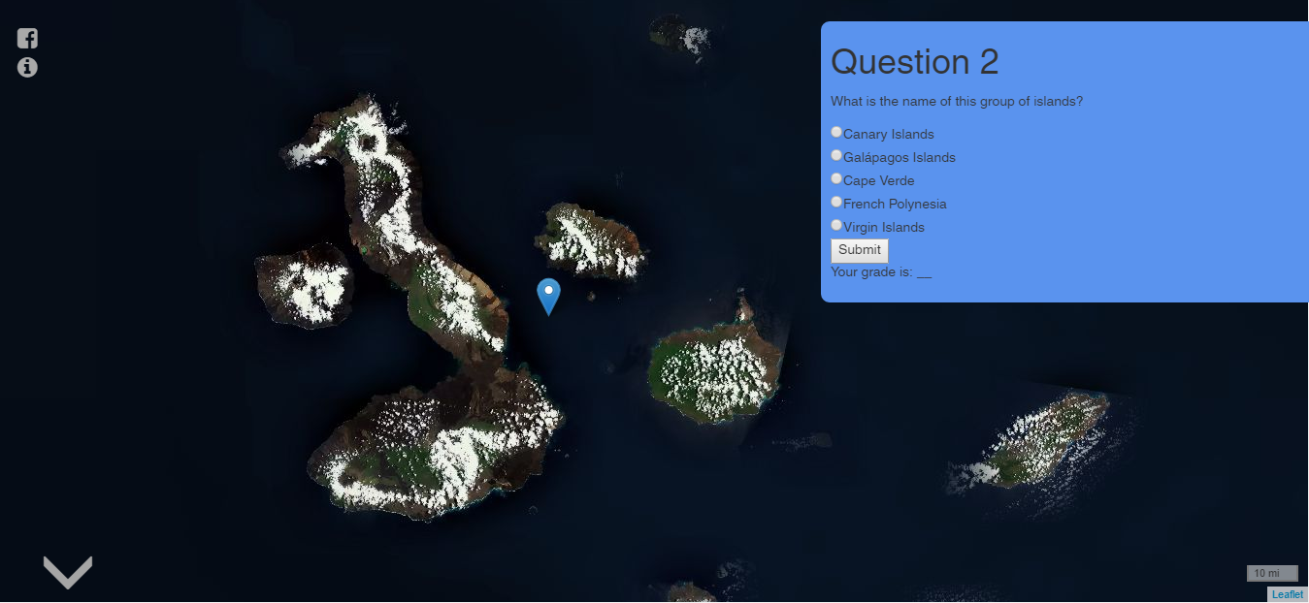

The user scrolls downward through the webpage to access each question. Each question is accompanied by a full screen satellite view of the area.

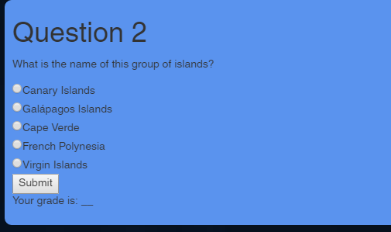

The user makes their selection by clicking on the corresponding white circle.

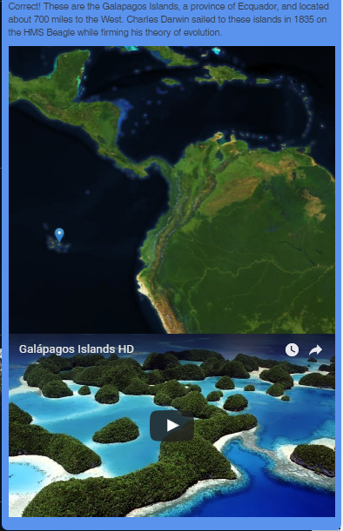

Once the user makes their selection, they are immediately told if they are correct or incorrect. Both messages are more or less the same. Regardless, they are also given a smaller scale map of the area, which should give full geographic context. In addition, each question has an relevant YouTube video embedded, which should give an intimate, social context of the area.

**SECTION III: Reflections**

Completing the project gave me valuable knowledge in game design, which can be translated into curriculum design. As a summer camp counselor, and a former environmental education intern, I have spent a lot of time building course curriculum and designing games for children. While this project in particular was designed for adults, the basic concepts are still present. I applied and enhanced these concepts while developing Satellite Riddles.